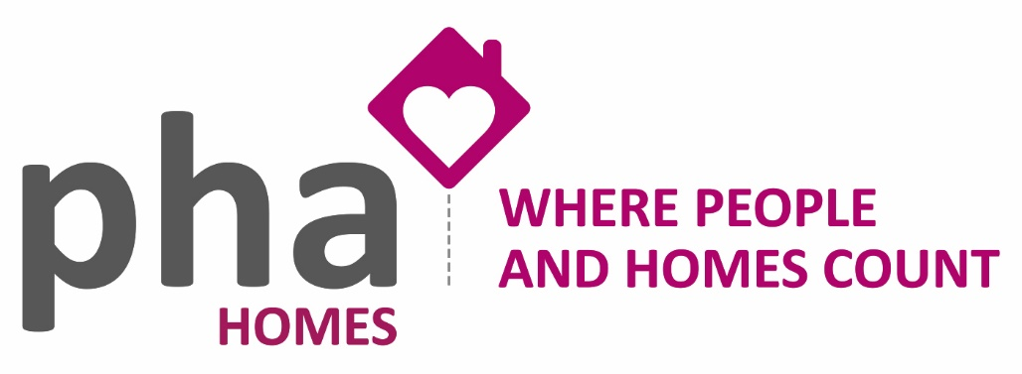

Mutual Exchange Information Sheet and Frequently Asked Questions

What is a mutual exchange?
If you want to move home, you can apply to swap homes with another PHA Homes tenant or a tenant of another housing association. This is called a mutual exchange.

You will not be able to exchange if you, or the tenant you want to exchange with, has a licence agreement, a probationary tenancy or an assured shorthold tenancy. Everyone involved needs to have permission from their landlord.

How do I find someone who wants to exchange?
You will find people who want to exchange properties by registering at www.homeswapper.co.uk. You can also check social media, i.e. Facebook pages. You could place an advert in a shop window and/or local paper.

What happens if the property needs decorating or repairs?
When you agree to a mutual exchange you are accepting the property as it is, so any decorating or repairs become your responsibility. If you are unsure of a responsibility item you should check with your new landlord before signing to take the property.

What about carpets and curtains?
You are responsible for fitting carpets, curtains, and curtain poles when you move in. You may agree with your exchange partner that they will leave their carpets and curtains for you.

If you decide when you move in that you no longer want them, you are responsible for removing them and PHA Homes does not accept liability.

What about removal costs?
You’ll need to arrange and pay for your own removals

What do I need to do to Mutual Exchange?
Before applying to all the landlords involved for approval to exchange properties, you should check the following:
- You have an Assured or Affordable Tenancy (not probationary or assured shorthold)
- You have a clear rent account and do not owe any money to PHA Homes for anything else, such as court costs or recharges
- You do not have an active Notice Seeking Possession or Court Order against the tenancy
- You have reported all outstanding repairs
- You have rectified any alterations and returned to PHA Homes standard, or if you have carried out any alterations without getting permission, you understand that you will be asked to make sure they meet our specification, or you may be charged for the cost of repairs
- Your home and garden are clean and tidy and in good condition and free from belongings and rubbish, including loft space, garages and communal areas
- The people applying to move into your home are suitable for it
- If you need to amend your tenancy in other ways, such as a change of name or from a joint tenancy to a sole name, this should be done before you apply to exchange.

Once your application has been received, your property will be inspected. Before the inspection, it is a good idea to have a look at whether your home is up to scratch and, if needed, spend some time putting things right.

You will need to make sure that we can easily view all rooms and walls. Please take down posters and pictures and move large furniture away from the wall. For further information please refer to the Tenants Property Checklist for detailed breakdowns of each aspect of the property.

Think carefully before agreeing to an exchange. Visit the property to make sure you are happy with the condition it is in. If you can, we recommend that you visit more than once at different times of the day and week.

What happens next?
Once you have found a suitable property, please ask for a mutual exchange application form by contacting the office. Once we have received application forms from all households involved, we will check them to make sure everything is OK.

If we are happy with all the application forms, we will contact you to arrange a property inspection. You will need to make sure your home is ready by this inspection, otherwise your application could be cancelled

PHA Homes must decide by law within 42 days of receiving the full completed application.
Sometimes we have to refuse an exchange for reasons such as but not limited to;
• Legal action is being taken against the resident(s) of one of the homes involved for a breach of tenancy
• The property would not suit the housing need (i.e. over-crowded or under-occupied)
• The exchange would mean that a home adapted for the elderly or disabled would be lived in by someone who did not need those adaptations
• The property is part of a sheltered scheme and the incoming resident is too young to live there
• The property is in poor condition
• The person you want to exchange with is not eligible, i.e. someone who has the income or savings to find their own home privately
• The property has a Section 106 agreement and the incoming tenant does not have a local connection.

When can I exchange?
You will be able to go ahead with the exchange only when written approval has been given by all landlords involved and tenancy documents have been signed.

Once you have moved
Remember to:
- Notify Housing Benefit or Universal Credit if you are in receipt of either of these
- Let your gas, electricity and water suppliers know and let them have your meter readings
- Inform the Council Tax team at your local council
- Redirect all your mail
- Update legal documents i.e. driving licence, passport, bank details
- We recommend you take out contents insurance to protect your personal belongings.

