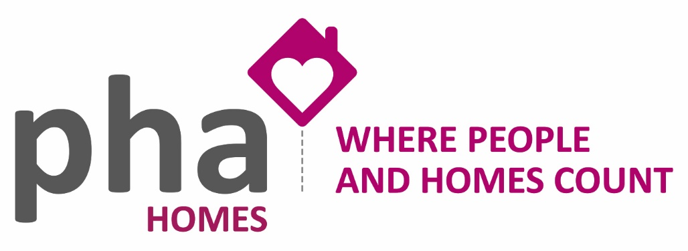
PHA Homes Privacy Notice
This Privacy Notice tells you what to expect when PHA Homes processes personal information. It applies to information about applicants, residents/customers and other service users. It tells you the purposes for which we may process your personal information and the legal basis for the processing (‘processing’ includes us just keeping your personal information).

PHA Homes is a controller of personal information for the purposes of the General Data Protection Regulation (‘GDPR’) PHA Homes needs to collect, process and store personal information about you and other household members (when you provide information about household members we assume that you do so with their full knowledge and consent) in order to operate as a registered provider of housing and deliver efficient and effective services.

Legal basis for processing
Our main legal basis for processing personal data is where it is necessary for the purposes of the legitimate interests pursued by PHA Homes or by a third party to process your information. We can do that so long as we do not interfere with your fundamental rights or freedoms.
The other reasons we can rely upon to process your personal information under GDPR is as follows:
- Since 25th May 2018 our residents were sent Privacy Statement and new tenants are given a Privacy Statement when they apply to us for housing. The statement sets out the organisations and type of organisations we often have to share personal information about residents with.
- Where we are under a legal obligation or an obligation under a contract to process/disclose the information;
- Where we need to protect the vital interests (i.e. the health and safety) of you or another person; and/or
- Some personal information is treated as more sensitive (for example information about health, sexuality, ethnic background and others). The basis we can use these are:
  - With your consent;
  - Where we need to protect the vital interests (i.e. the health and safety) of you or another person;
  - Where you have already made your personal information public;
  - Where we or another person needs to bring or defend legal claims; and/or
  - Substantial public interest grounds.
The information we hold on our records concerns our relationship with you. For example:
- We hold names & dates of birth and information about your previous housing circumstances to assess housing applications and help prevent tenancy fraud.
- We hold contact details for you, so we can communicate with you by your preferred means, and keep you informed about services we offer which may be useful to you.
- We record information about your needs (for example if you have a carer or social worker; if you need adaptations in your home; if you need large print or translated text) to ensure that we take account of any support needs in our dealings with you, and to improve our communications with you.
- We record information to enable us to provide housing management services. For example, we record reports of anti-social behaviour; complaints; change in circumstances (for example when your employment status changes etc.) and information about housing options (e.g. if you have a medical need which means you need to move).
- We keep financial records about the amount of money you have paid us; any amount(s) outstanding, action taken to recover money you owe and to assess affordability for home ownership products that we offer;
- We may record your telephone calls to us for training and monitoring purposes to ensure we are delivering a good service. Any call recordings will be held in accordance with our corporate retention policy before being erased.
- We record the findings of surveys and other research to help us improve our service to customers. The information you provide will be anonymous unless you agree that we can use your details.
This list is not exhaustive, as we hold records of most contacts we have with you, or about you, and we process this information, so we can deliver services to you. Generally, the information we hold will have been provided by you (on application or enquiry forms or when we communicate with you), but we may also hold information provided by third parties where this is relevant to your housing circumstances e.g. from social workers and health professionals (such as doctors and occupational therapists).
We will only ask for personal information that is appropriate to enable us to deliver our services. In some cases, you can refuse to provide your details if you deem a request to be inappropriate. However, you should note that this may impact our ability to provide some services to you if you refuse to provide information that stops us from doing so.

How we manage your personal information
We process your personal information in accordance with the principles of GDPR.
We will treat your personal information fairly and lawfully and we will ensure that information is:
- Processed for limited purposes;
- Kept up-to-date, accurate, relevant and not excessive;
- Not kept longer than is necessary;
- Kept secure.
Access to personal information is restricted to authorised individuals on a strictly need to know basis.
We are committed to keeping your personal details up to date, and we encourage you to inform us about any changes needed to ensure your details are accurate.
To help us to ensure the security and confidentiality of your personal information we may ask you security questions to confirm your identity when you contact us and before we can process your call or enquiry further. We will not discuss your personal information with anyone other than you, unless you have given us prior authorisation to do so.

Periods for which we will store your personal information
We will only hold your records during the period of our relationship with you and for a set period afterwards to allow us to meet our legal obligations including resolving any follow up issues between us (for example if you live in one of our properties we will hold information about you for the duration of your tenancy).

Normally, only PHA Homes staff will be able to see and process your personal information. However, there may be times when we will share relevant information with third parties for the purposes as outlined above, or where we are legally required to do so. When sharing personal information, we will comply with all aspects of the GDPR. Special categories of personal data about health, sexual life, race, religion and criminal activity for example is subject to particularly stringent security and confidentiality measures and we will seek your specific consent before sharing this information.

Where necessary or required, we may share information as follows:
- comply with the law (e.g. the police, Inland Revenue, Council Tax Registration Officer, Social Security Fraud Act) or a court order;
- where there is a clear health or safety risk to an individual or members of the public;
- where there is evidence of fraud against PHA Homes, other irregular behaviour or a matter PHA Homes is investigating such as illegal subletting (e.g. credit reference agencies);
- in connection with court proceedings or statutory action to enforce compliance with tenancy conditions (e.g. applications for possession or for payment of Housing Benefit direct);
- where PHA Homes has entered into a formal protocol with the police or a local authority department;
- providing the name, address and contact number of a resident to contractors or other agents providing services on PHA Homes’ behalf;
- providing the name of a resident and the date of occupancy to gas, electricity and water companies and their representatives;
- providing information anonymously for bona fide statistical or research purposes, provided it is not possible to identify the individuals to whom the information relates;
- giving the name, address and stated local connection of applicants for housing to parish councils, other housing associations, trusts and landlords in connection with tenancy references and associated enquiries for housing which gives priority to people with a local connection;
- information required by the Social Housing regulator when monitoring PHA Homes activities in its capacity as the regulator of housing associations.
- information required by the Ministry for Housing, Communities and Local Government (MHCLG) for the CORE (COntinuous REcording of social housing lettings and sales) scheme for statistical purposes, in the public interest.
- the names of contractors invited to tender for works and the amounts tendered will be made available to residents paying service charges to which the cost of the works will be charged (Section 20 Landlord and Tenant Act 1985, as amended);
- with post sales mortgage administrators, independent financial advisors, solicitors and developers to progress applications for home ownership products;
- to protect the vital interests of an individual (in a life or death situation).

Data matching

PHA Homes may use a data matching process, where appropriate, to prevent fraud. This involves comparing sets of data, such as the payroll or benefits records of a body, against other records held by the same or another body to see how far they match. The data is usually personal information.

Data matching allows potentially fraudulent claims and payments to be identified. Where a match is found it may indicate there is an inconsistency that requires further investigation. No assumption will be made as to whether there is fraud, error or other explanation until an investigation has been carried out.

Disclosure Policy

We reserve the right to access and disclose individually identifiable information to enable us to comply with applicable laws and lawful government requests to operate its systems and to protect itself or its users.
You have a number of rights under the GDPR:

Access to personal information
Under the GDPR, you have a right to ask us what personal information we hold about you, and to request a copy of your information. This is known as a ‘subject access request’ (SAR). SARs need to be made in writing and we ask that your written request is accompanied by proof of your identify. We have one calendar month within which to provide you with the information you’ve asked for (although we will try to provide this to you as promptly as possible).

Following your SAR, we will provide you with a copy of the information we hold that relates to you. This will not generally include information that relates to your property such as repair logs or details of contractor visits, as this is not considered personal information.

Rectification
If you need us to correct any mistakes contained in the information we hold about you, you can let us know by contacting PHA Homes by telephone on 01730 263589 or admin@phahomes.co.uk

Erasure (‘right to be forgotten’)
You have the right to ask us to delete personal information we hold about you. You can do this where:
- the information is no longer necessary in relation to the purpose for which we originally collected/processed it;
- where you object to the processing and there is no overriding legitimate interest for us continuing the processing;
- where we unlawfully processed the information; and/or
- the personal information has to be erased in order to comply with a legal obligation.

We can refuse to erase your personal information where the personal information is processed for the following reasons:
- to exercise the right of freedom of expression and information;
- to enable functions designed to protect the public to be achieved e.g. government or regulatory functions;
- to comply with a legal obligation or for the performance of a public interest task or exercise of official authority;
- for public health purposes in the public interest;
- archiving purposes in the public interest, scientific research historical research or statistical purposes;
- the exercise or defence of legal claims; or
- where we have an overriding legitimate interest for continuing with the processing.

Restriction on processing
You have the right to require us to stop processing your personal information. When processing is restricted, we are allowed to store the information, but not do anything with it. You can do this where:
- You challenge the accuracy of the information (we must restrict processing until we have verified its accuracy);
- You challenge whether we have a legitimate interest in using the information;
- If the processing is a breach of the GDPR or otherwise unlawful; and/or
- If we no longer need the personal data but you need the information to establish, exercise or defend a legal claim.
If we have disclosed your personal information to third parties, we must inform them about the restriction on processing, unless it is impossible or involves disproportionate effort to do so.
We must inform you when we decide to remove the restriction giving the reasons why.

Objection to processing
You have the right to object to processing where we say it is in our legitimate business interests. We must stop using the information unless we can show there is a compelling legitimate reason for the processing, which override your interests and rights, or the processing is necessary for us or someone else to bring or defend legal claims.

Withdrawal of consent
You have the right to withdraw your consent to us processing your information at any time. If the basis on which we are using your personal information is your consent, then we must stop using the information. We can refuse if we can rely on another reason to process the information such as our legitimate interests.

Right to data portability
The right to data portability allows us to obtain and reuse your personal data across different services. It allows us to move, copy or transfer personal data easily from one IT environment to another in a safe and secure way. The right only applies to personal data you have provided to us where the reason we are relying on to use the information is either your consent or for the performance of a contract. It also only applies when processing is carried out by us using automated means.

Changes to this Privacy Notice
We keep our privacy notice under regular review and will place any updates on our website; you will be notified of any major changes to it.

For further information on how to request your personal information and how and why we process your information, you can contact us using the details below:
admin@phahomes.co.uk

Tel: 01730 263589

The Information Commissioner’s Office (ICO) is also a source of further information about your data protection rights. The ICO is an independent official body, and one of their primary functions is to administer the provisions of the GDPR.
You have the right to complain to the ICO if you think we have breached the GDPR. You can contact the ICO at:
Information Commissioner's Office, Wycliffe House, Water Lane, Wilmslow, Cheshire, SK9 5AF
http://www.ico.org.uk/
0303 123 1113

