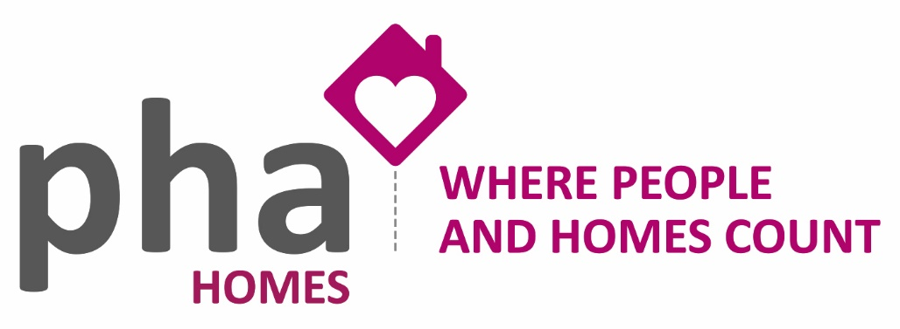

THE COST-OF-LIVING CRISIS
Initiatives to help households

We are approaching an Autumn/Winter of high inflation, increasing fuel and food costs, increasing taxes and rents, and a significant impact on everyone’s day-to-day living costs. PHA Homes aim is to provide tenants with information on how you can either maximise your income by accessing grants/financial assistance or reducing your bills.

If you are struggling, then please contact the office on 01730 263589 or via admin@phahomes.co.uk

What has been announced?
- £2,500 Energy Price Guarantee
- Energy support scheme of £400 for all households
- £650 one-off cost of living payment
- One-off £300 Pension Cost of Living payment
- £150 Disability Cost of Living Payment

£2,500 Energy Price Guarantee

The new Energy Price Guarantee (EPG) has recently been announced by the Government and will cap the average household’s energy usage at £2,500. This will come into effect on October 1 and take over the current price cap, lasting for two years and will be applied when your next bill is calculated.

The cap is on standing charges and unit rates so the more you use, the more you will pay.
For pre-payment meter customers, the EPG will be applied to the rate you pay for each unit of energy, so the money you put on the meter will last longer than would otherwise have been the case this winter.

So far, consumers will not have been contacted directly about this and are unlikely to be as it will apply to all households across the country. Your energy supplier may contact you regarding the Guarantee. Any queries or concerns regarding the cap should be directed to your provider.

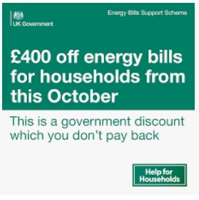
Energy Bill Discount
All households will receive a Energy Bill discount of £400 – paid in 6 instalments of £66 between October 2022 – March 2023. You do not need to apply for this Discount and you will not be asked to provide your bank details.
Warning: Ofgem or energy companies will never ask for your bank details in relation to energy bill. If you receive an email offering an energy rebate do not click on any links or give any personal banking details.

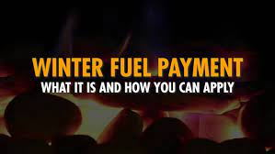
Winter Fuel Payment

A Winter Fuel Payment is a one-off tax free payment made during the winter to help with heating costs. It is made to households that include someone over state pension age. Most payments are made automatically between November and December. The amount paid is between £100 and £300.

Contact details: 0800 731 0160

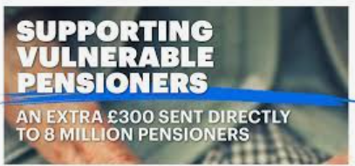
Pensioner Cost of Living Payment
In addition to the Winter Fuel payment this winter pensioners will also receive an extra one-off £300 Pensioner Cost of Living Payment, which will be paid as an automatic top-up to the Winter Fuel Payment.

Cost of Living Payment
Not all of our tenants are in receipt of a state pension. There is help for those who are still working. Households on means tested benefits, including Universal Credit, Pension Credit and Tax Credits, will receive a payment of £650 this year.
This will be made automatically in two instalments, one in summer and another in the autumn, and is in addition to the £400 discount on energy bills.

Disability payments
Individuals on disability benefits will receive a one-off £150 payment in September to help with extra costs, such as for specialist equipment or transport.
This is in addition to the £650 Cost of Living Payment for disabled people who also receive means tested benefits.

Cold Weather Payments
If you get certain benefits, you may get a Cold Weather Payment. This is paid if the average temperature in your area is recorded as, or forecast to be, zero degrees celsius or below over 7 consecutive days.

Warm Home Discount Scheme
You could get £140 off your electricity bill under this scheme. The money is not paid to you, it is a one-off discount on your electricity bill between October and March. This sum is in addition to any Winter Fuel Payment or Cold Weather Payment.

Behind on you gas and electricity bills?
If you are in arrears or are struggling with debts you are repaying you can ask your supplier to reduce or temporarily stop the deductions. Contact your supplier direct to discuss the best option for you.

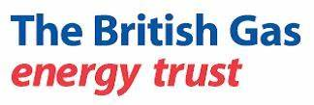
No matter what energy company you are with British Gas Energy Trust may be able to help. They are an independent charitable trust set up to support families and individuals facing financial hardship and energy debt. www.britishgas.co.uk or telephone 01213 487797.

British Gas have just announced that they are donating 10% of their profits from energy (£12 million) to cut fuel bills via this fund. The average grant will be £250 to £750. You must have less than £1,000 in savings and be in fuel poverty to qualify.

MAXIMISE YOUR INCOME!

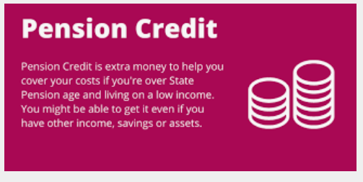
It is really important that you claim the benefits you are entitled to. Not just because it will increase your income but also it often means you can access other financial help. If you are not yet on a State Pension there are other benefits you can claim.

Pension Credit is extra money to help you cover your costs if you’re over State Pension age and living on a low income. You might be able to get it even if you have other income, savings or assets. Pension Credit tops up your weekly income to a guaranteed minimum level for 2022/2023 of £182.60 if you are single and £278.70 if you’re a couple. Even if you have savings you could get up to £14.48 extra a week if you are single and £16.20 if you’re a couple.

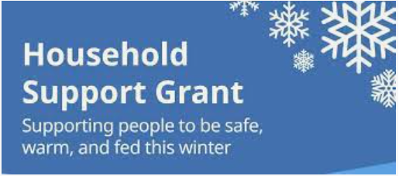
£1.5 billion has been made available to support the most vulnerable to cover their essential daily costs, like energy bills. Recipients include pensioners. East Hampshire District Council can help you with a range of support including Council Tax and Housing Benefits, Discretionary Housing Payments.

Local Foodbanks – PHA Homes can provide referrals for all local foodbanks

Petersfield – East entrance, Methodist Church, Station Road, Petersfield GU32 3EB
on Tuesday and Friday mornings 9.30am – 11.30am.

Alton – 15 Market Street, Alton, Hampshire, GU34 1HD on Tuesday 6.30-7.30 pm, Wednesday 12.30-2.00 pm; Saturday 10.30-12.00 noon
Info@alton.foodbank.org.uk / 07773 034447

The foodbanks provide three days’ nutritionally balance emergency food and support to local people who are referred to them in crisis. They are part of a nationwide network of foodbanks, supported by the Trussell Trust, working to combat poverty and hunger across the UK.

East Hampshire District Council

01730 234 175 / www.easthants.gov.uk
You may be entitled to housing benefit or council tax reduction as a way of reducing the amount of money that you pay out.

Housing Benefit helps people on low incomes with the cost of their rent and is paid by the local council.

Council Tax Reduction helps people on low incomes with the cost of their council tax and is paid by the local council. It is a means tested discount that reduces your council tax bill. It is not a benefit.

The Council recently launched a new wellbeing assessment tool to help residents that may be struggling to pay their council tax bills.
People whose payments are overdue will receive a text message inviting them to complete a TellJO wellbeing survey, which will help the Council identify ways to help you. Debt or benefit advice is available and tenants may be eligible for discounts they didn’t know about; this includes support payments for people struggling financially.

Useful Contacts:

Citizens Advice Centre

Petersfield Library, 2nd Floor 27 The Square
PETERSFIELD
Hampshire
GU32 3HH
http://www.citizensadvice.org.uk/east-hampshire / 0808 278 7901

The Citizens Advice Bureau offer free advice that is independent, confidential and impartial. They can help with debt advice.

National Debt Helpline – 0808 808 4000 or https://www.nationaldebtline.org
Age UK – 0800 169 6565 or https://www.ageuk.org.uk

