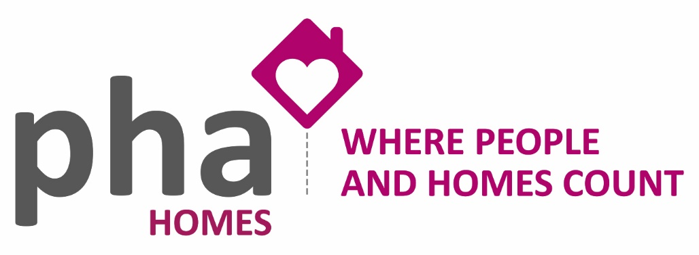
Rent Payment Dates 2023
The other terms and conditions of the tenancy are detailed in your tenancy agreement.
If you have an assured tenancy or an assured agricultural occupancy you have certain rights under the Housing Act 1988. These include the right not to be evicted from your home unless your landlord gets a possession order from the courts. Unless the property is let under an assured shorthold tenancy, the courts can only grant an order on a limited number of grounds. Further details regarding assured tenancies are set out in the [Department of the Environment, Transport and the Regions] and Welsh Office booklet "Assured Tenancies" no. 19 in the series of housing booklets. These booklets are available from rent officers, council offices and housing aid centres, some of which also give advice.
You may be entitled to get help to pay your rent through the housing benefit scheme. You will need to apply to your local council for details.
It is a criminal offence for your landlord to evict you without an order from the court or to harass your or interfere with your possessions or use of facilities in order to force you to leave.
If you are in any doubt about your legal rights or obligations, particularly if your landlord has asked you to leave, you should go to a Citizens' Advice Bureau, housing aid centre, law centre or solicitor. Help with all or part of the cost of legal advice from a solicitor may be available under the Legal Aid Scheme.
Rent can be paid by cash or cheque in the Association’s office or by standing order or direct debit with your Bank or Building Society or at the Post Office or PayPoint using a payment card. You can also pay by debit card over the telephone.

Landlords Registered Office:
PHA Homes
32, Dragon Street,
Petersfield,
Hampshire GU31 4JJ
Telephone: 01730 263589

2023 Rent Payment Dates
Monthly

January 1st
February 1st
March 1st
April 1st
May 1st
June 1st
July 1st
August 1st
September 1st
October 1st
November 1st
December 1st

