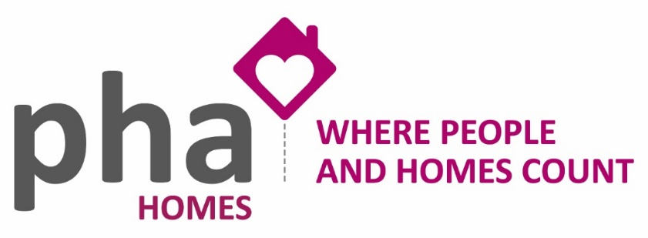

**Tenant Satisfaction Measures 2023**

We would like to thank everyone who participated in our Tenant Satisfactions Measures (TSM) survey in Spring 2023.

96% of our general need’s accommodation took part via phone, text, email, and post, which gave us a really good basis to work from.

The surveys are part of a requirement of the Government’s charter for social housing residents: social housing white paper and were published by the Regulator of Social Housing in order to ensure the sector commits to providing good quality homes and services and works to overcome any structural inequalities.

Part of the requirements is to provide transparency. We have already shared the results with our Board and Tenant Engagement Panel (TEP), but we want to share our results with everyone else too.

**Areas that provided sector beating results**

preencoded.pngpreencoded.pngpreencoded.pngpreencoded.pngpreencoded.pngpreencoded.png

**92%**

Overall Satisfaction with Services

**91%**

Satisfied that their home is well maintained

**94%**

Satisfied that their home is safe

**93%**

Feel we treat people fairly and with respect

**91%**

Satisfied that communal areas are clean and well maintained

**91%**

Feel we keep them informed about things that matter to them

**Areas that we feel we can work on to improve**

preencoded.pngpreencoded.pngpreencoded.pngpreencoded.pngpreencoded.pngpreencoded.png

Of those who had complained, were satisfied with how we handled it

**81%**

Feel we listen to residents and act on their views

**75%**

Feel we make a positive contribution to the neighbourhood

**68%**

Are satisfied with the overall repairs service in past 12 months

**66%**

Are satisfied with the time taken to complete the most recent repair

**53%**

**87%**

Satisfied with our response to Anti-Social Behaviour

**What are we doing about improving our services?**

|  |
| --- |
| **Action** |
| 1. Work in collaboration with the relevant persons, e.g., Hampshire Highways, to resolve matters which fall outside of PHA Homes responsibilities (e.g., streetlights not working or grass which is not part of our land) |
| 1. Improve communication between PHA Homes, contractors, and tenants by keeping them informed better |
| 1. Share our results from the TSM surveys with our Tenant Engagement Panel during the Q2 TEP meeting |
| 1. Display our results on our website for openness and transparency |
| 1. Discuss the possibility of providing more flexible appointments for visits / repairs for tenants that work full time |
| 1. Contact all unsatisfied respondents to discuss in person, or over the phone, wherever possible |
| 1. Explain our processes to those that provided dissatisfied responses around ASB to give reassurance and educate those who feel we may not be addressing such matters |
| 1. Arrange some additional training on ASB for front line staff members |
| 1. Query the non-applicable elements with the Regulator of Social Housing for clarity next time |
| 1. Complete leaseholder and Shared Owner TSM’s |
| 1. Update any changes to household, contact or vulnerability details which may have been noted on the call to ensure our records are fully up to date |

**Overall**

The response rate to the surveys completed has been phenomenal – the best PHA Homes has ever received. PHA Homes see the TSMs as a very positive part of engaging with tenants and improving the services we provide.

PHA Homes has received good results, but there are always ways we can improve and there are certainly some areas to focus on initially, as detailed in the action plan to ensure our tenants have good quality homes and services.

Currently there is not much comparable data, but we have outperformed other organisations that have shared their data. We will continue to monitor results to see how we compare.

We may look to complete future surveys externally by a third party. We should be aware that this could provide us with a drop in our results and have a cost implication, but it may provide different results.